**Region B**

This is the smallest region in Canada but the population is large here. People are attracted to the fertile farmland and the many waterways that make up this region. In fact, waterways like the ST. Lawrence River and Great Lakes play an important role in people's lives and jobs.

Due to a mild climate, hot and humid in the summer and lots of snow in the winter, many people work in agriculture. However agriculture is not the only industry, other people work in manufacturing and tourism. People enjoy lots of outdoor activities in this region. 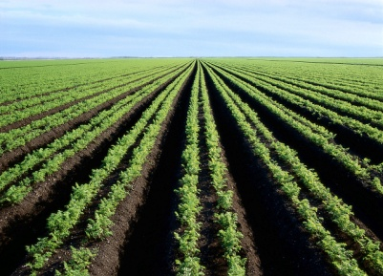

In this region, you will find some of Canada's largest cities. This was the area where European settlers first settled and many ships bringing immigrants to Canada landed here. Natural resources, like forests, rivers, lakes, and rich soil have lead to many people putting down roots here.

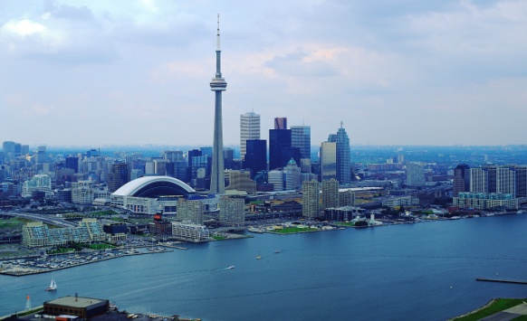 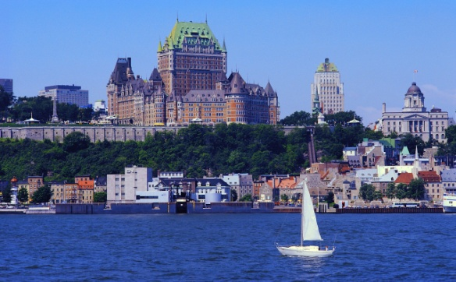

Look at Chapter 3 in the textbook for more information.